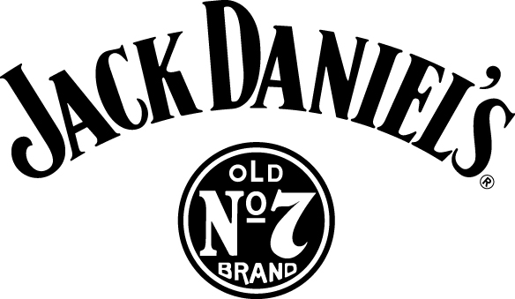

FOR IMMEDIATE RELEASE Contact: Mark L. Day
(615) 780-3345
mark.day@dvl.com

JACK DANIEL DISTILLERY PETITIONS U.S. POSTAL SERVICE
FOR STAMP TO HONOR FOUNDER ON 150TH ANNIVERSARY

LYNCHBURG, Tenn. (September 25, 2014) -- In honor of its 150th Anniversary as America’s oldest registered distillery in 2016, the Jack Daniel Distillery today petitioned the U.S. Postal Service to create a new stamp in tribute to the founder, Jasper Newton “Jack” Daniel.

In its letter of request to Postal Service’s Citizens’ Stamp Advisory Committee, the distillery said that the request for a Jack Daniel stamp met the subject selection criteria, including being an American, honoring those men and women who have made extraordinary contributions to American society and celebrating events of historical significance.

“Mr. Jack was a remarkable man and we think a stamp would be a fitting tribute,” said Jeff Arnett, only the seventh Master Distiller for the famed whiskey maker. “Jack’s life is a classic American story, setting out on his own at an early age to become the founder of what would become our country’s oldest registered distillery.”

Arnett pointed to recent stamp subjects under consideration by the Postal Service who have influenced popular culture in America and said that “Mr. Jack would fit right in” with those other icons.

Jack Daniel created a brand that holds a unique place in history and popular culture. Sold in more than 160 countries around the globe, Jack Daniel’s Tennessee Whiskey is a symbol of America’s independent spirit and small-town ingenuity. His whiskey has graced the stage with countless musicians beginning with the “Chairman of the Board,” Frank Sinatra, to sharing the spotlight in numerous Hollywood films.

Established and registered by the U.S. Government in 1866, the Jack Daniel Distillery is the oldest registered distillery in the United States and is listed on the National Register of Historic Places. Every year about 250,000 people tour the distillery and visit the small town of Lynchburg, Tennessee, where Jack Daniel lived until his death in 1911.

###

Please Drink Jack Daniel’s Responsibly.

About Jack Daniel’s

Officially registered by the U.S. Government in 1866 and based in Lynchburg, Tenn., the Jack Daniel Distillery, Lem Motlow, proprietor, is the oldest registered distillery in the United States and is on the National Register of Historic Places. Jack Daniel’s is the maker of the world-famous Jack Daniel’s Old No. 7 Tennessee Whiskey, Gentleman Jack Rare Tennessee Whiskey, Jack Daniel’s Single Barrel Tennessee Whiskey, Jack Daniel’s Tennessee Honey and Jack Daniel’s Country Cocktails.

